# Ensuring that PDFs are accessible

The first step in making PDFs accessible is ensuring that the original document uses proper formatting (using headers correctly, adding alt tags to any embedded images, using proper text formatting vs using TAB to create spaces). Once the original document is converted to PDF, editing for accessibility will be easier and faster.

**Certified files such as Meeting Minutes should also be tagged for accessibility before it is sent on to be signed and certified.** Once a file is certified, it is locked and cannot be re-edited/tagged for compliance.

Section508.gov has excellent guidance on creating accessible documents found in the link below, with training videos, guidelines, and tips on how to make the job easier:

* [Create Accessible Documents | Section508.gov](https://www.section508.gov/create/documents/) – creating accessible Word documents
* [Presentations Authoring Guides | Section508.gov](https://www.section508.gov/create/presentations/authoring-guides/) – creating accessible PowerPoint
* [Spreadsheets Authoring Guides | Section508.gov](https://www.section508.gov/create/spreadsheets/authoring-guides/) – creating accessible Excel Spreadsheets
* [PDFs Authoring Guides | Section508.gov](https://www.section508.gov/create/pdfs/authoring-guides/) – creating accessible PDFs.

The following guide can be used for pdfs already uploaded on to the site.

# Autotagging a PDF and running an Accessibility Test

### **RESOURCES**

* [Create and verify PDF accessibility, Acrobat Pro (adobe.com)](https://helpx.adobe.com/acrobat/using/create-verify-pdf-accessibility.html)
* [PDFs Authoring Guides | Section508.gov](https://www.section508.gov/create/pdfs/authoring-guides/)
* [PDFs: A Digital Content Detour – Digital.gov](https://digital.gov/2015/07/23/pdfs-a-digital-content-detour/)

1. Open PDF in Adobe Acrobat Pro and click on **Tools** on the upper left of the screen

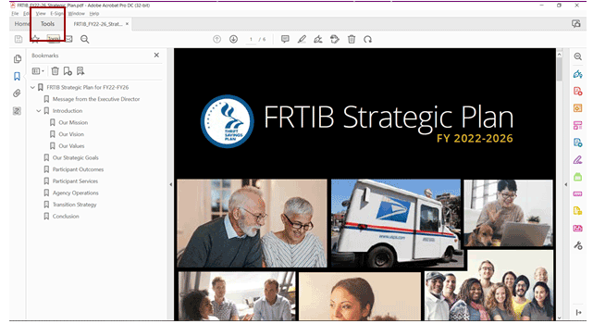

1. Scroll to PROTECT AND STANDARDIZE section and click on **Accessibility.** Click on ADD to add to the right hand Tool pane when editing the PDF for easy access.

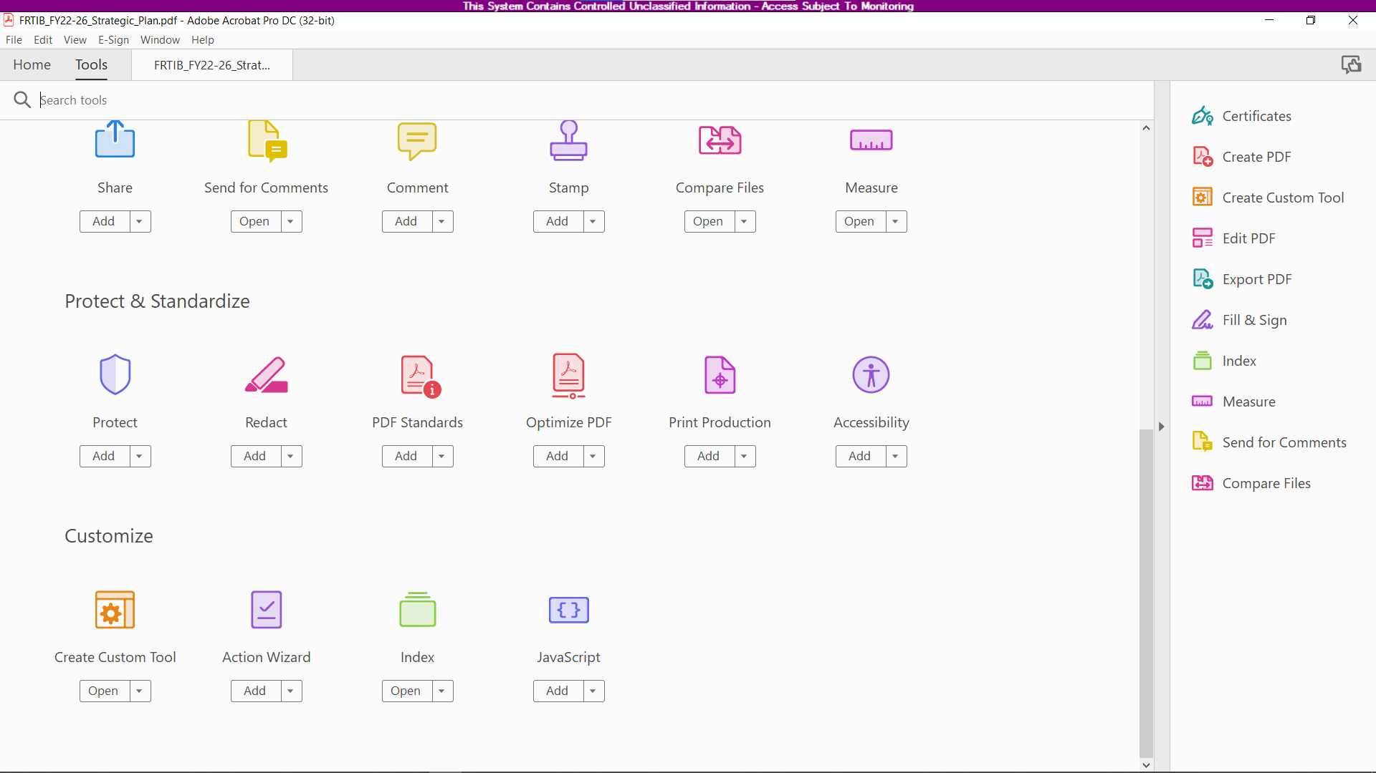

1. On the right pane, click on first link: **Autotag Document.**

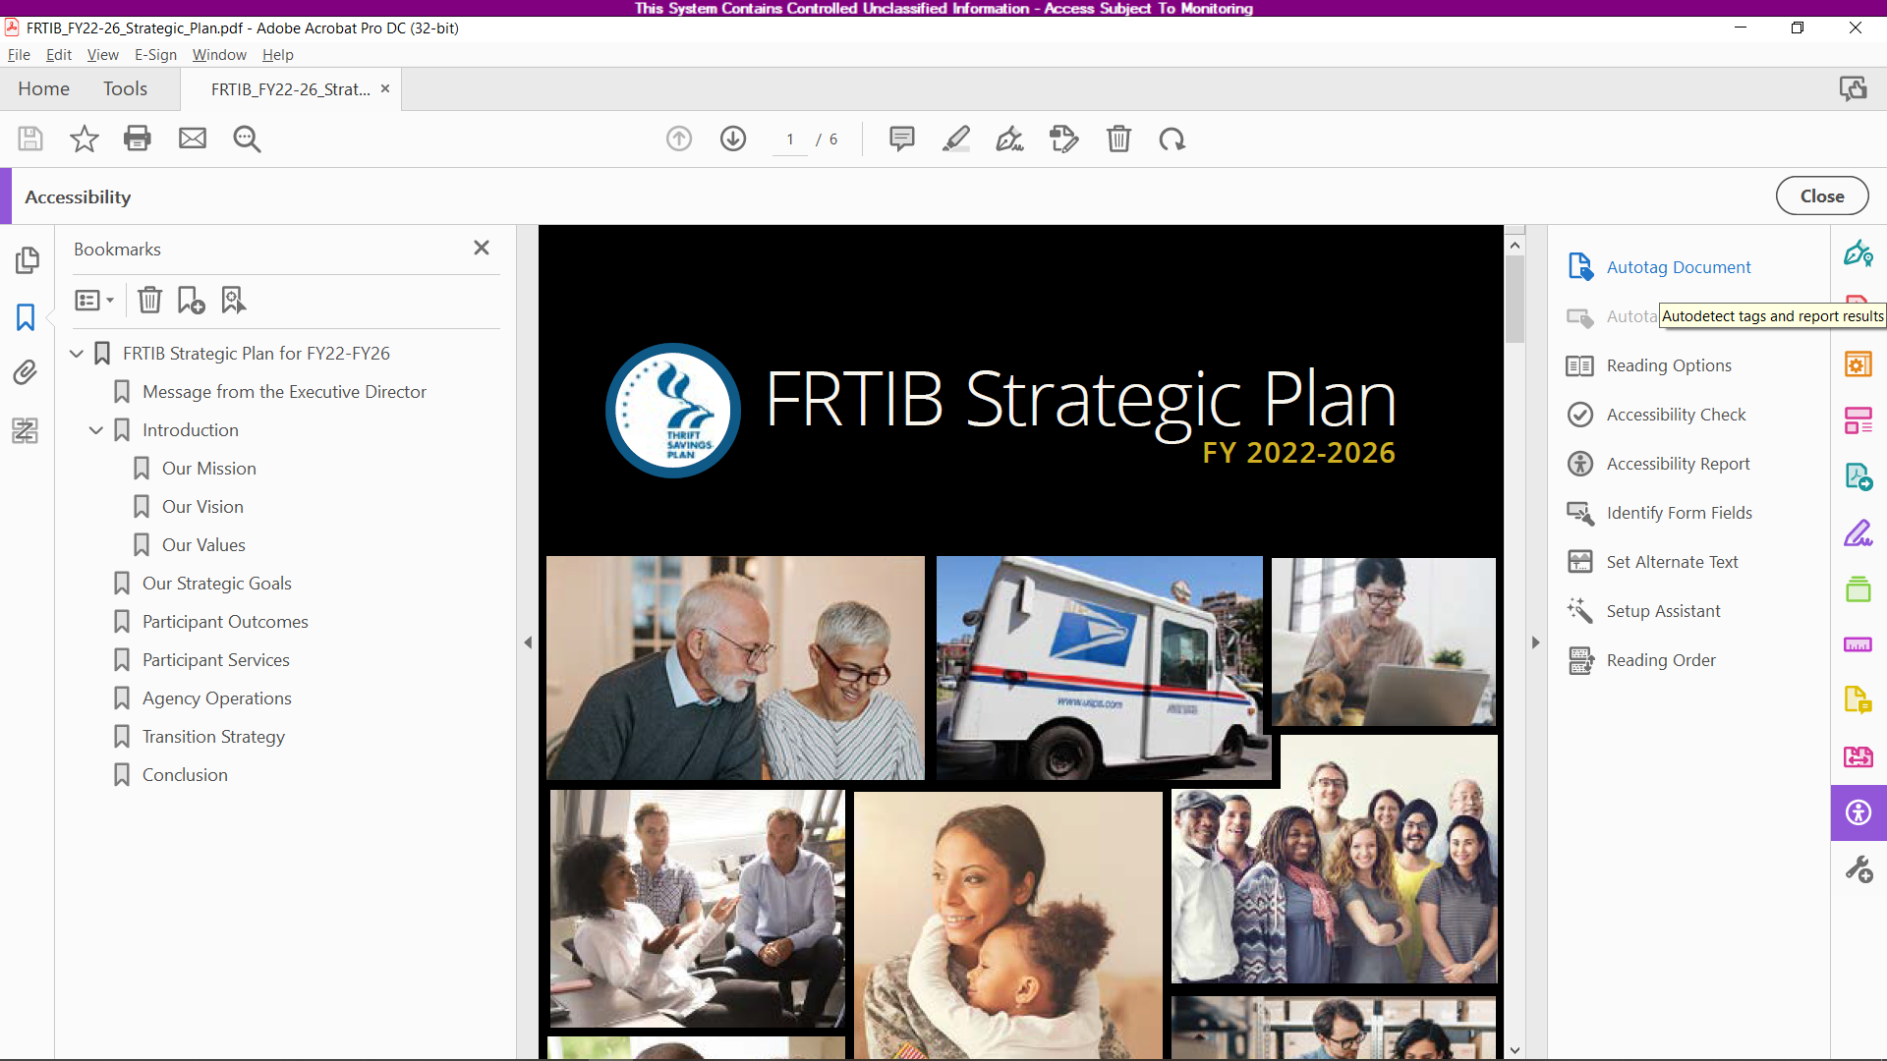

1. Once Autotagging is completed, a Recognition Report will appear on the left pane. This lists out a set of issues found that will need manual tagging.

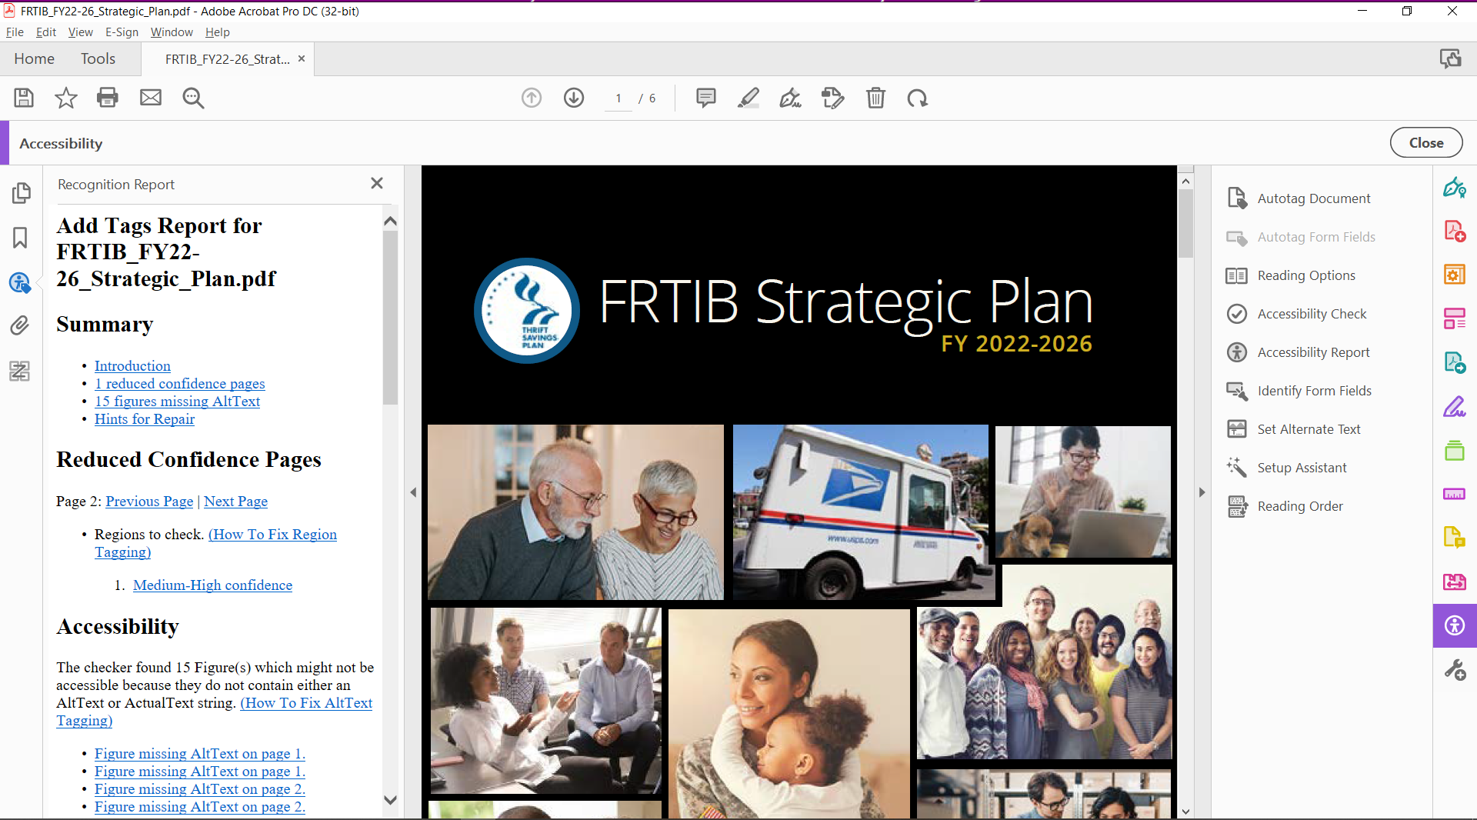

1. On the right pane, click on **Accessibility Check**.

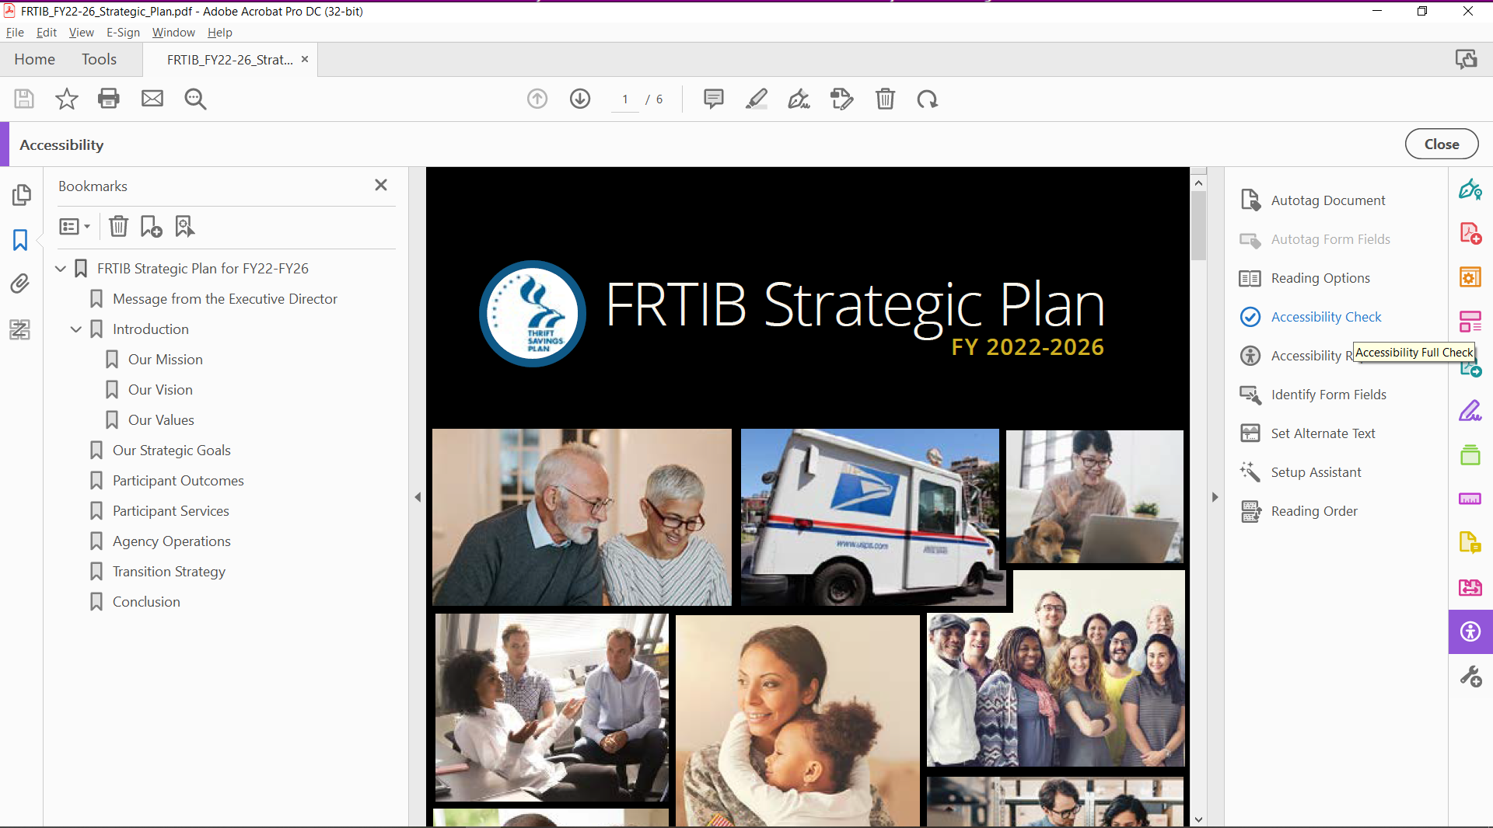

1. Choose where to save the report, and make sure all fields are checked under **Checking Options**. Click on the **Start Checking** button.

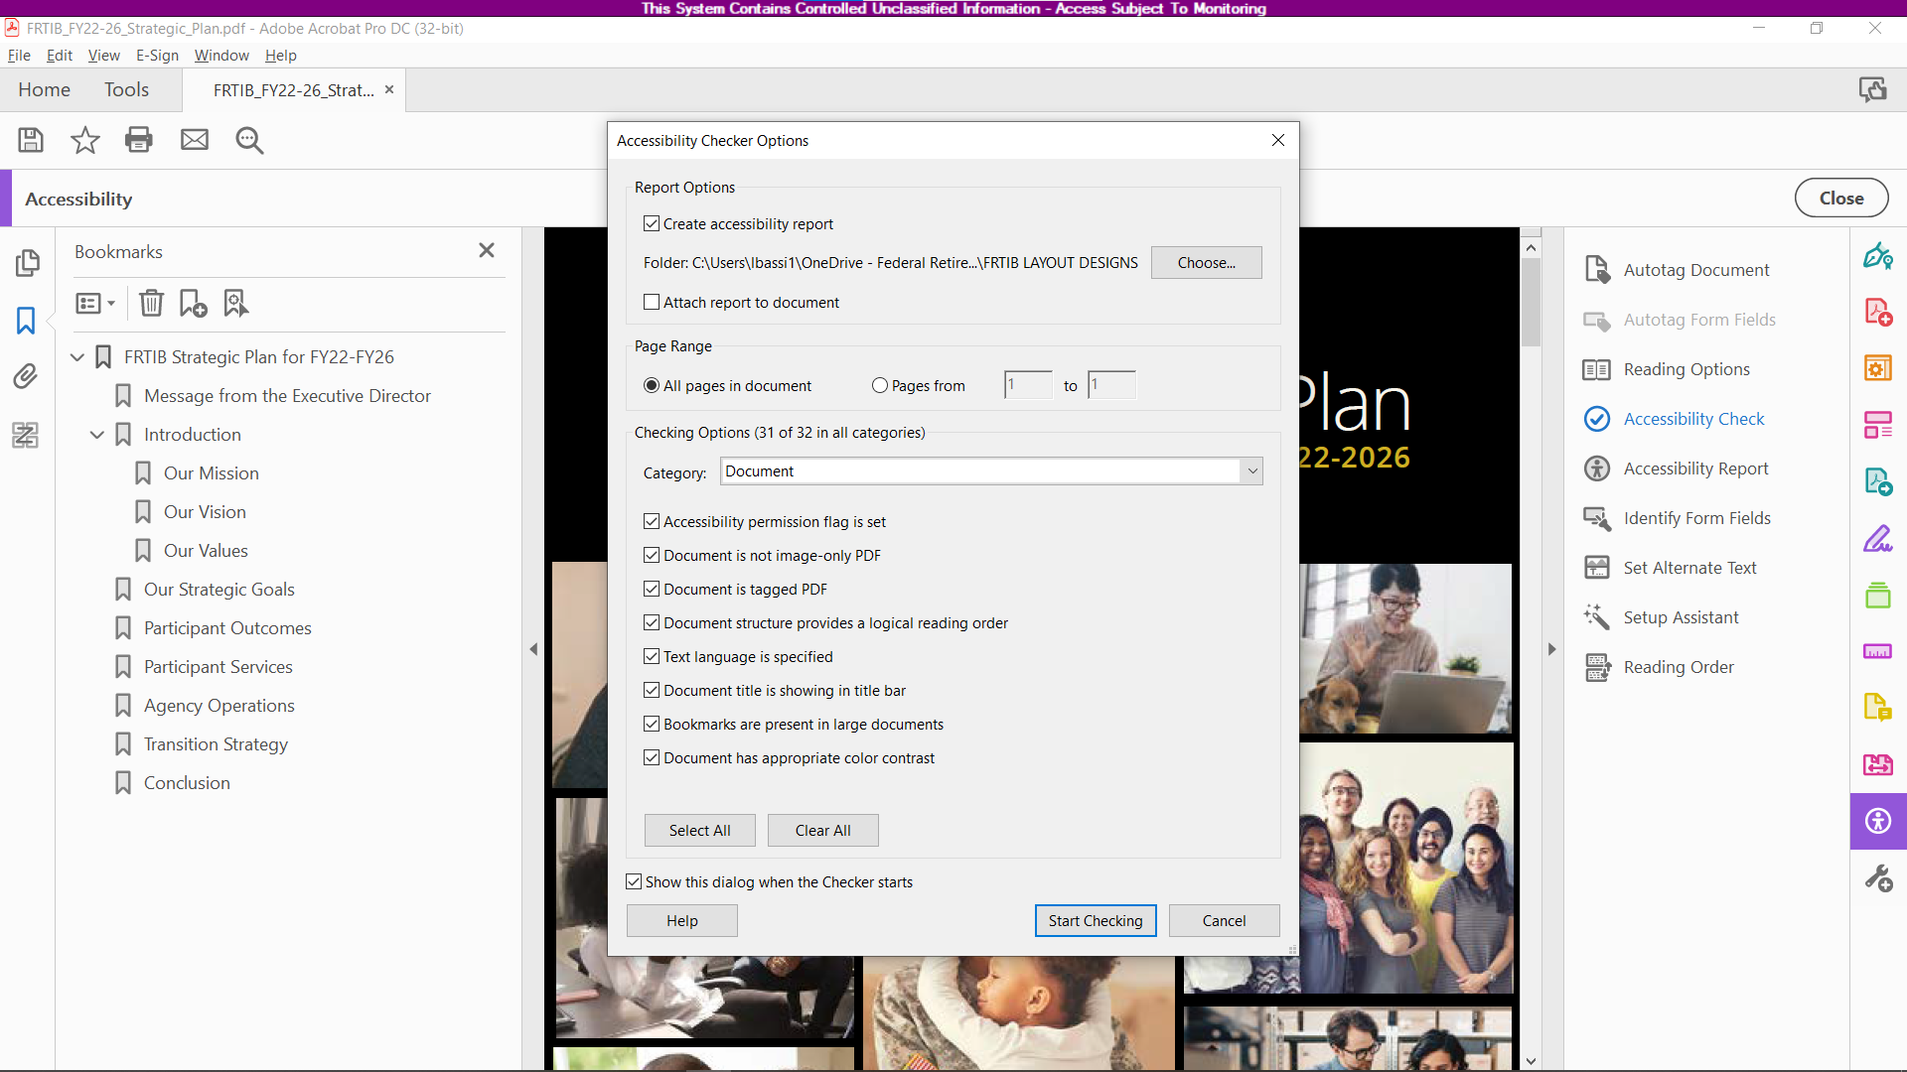

1. Accessibility Checker report will show up on the right pane, listing all issues that still need a manual fix. Right clicking on an issue will show a popup with options Pass, Fail, Skip Rule, Explain, Check Again, Show Report, Options. Clicking on Explain will open a browser window I (<https://helpx.adobe.com>) that explains the issue in more detail, and possible solutions.

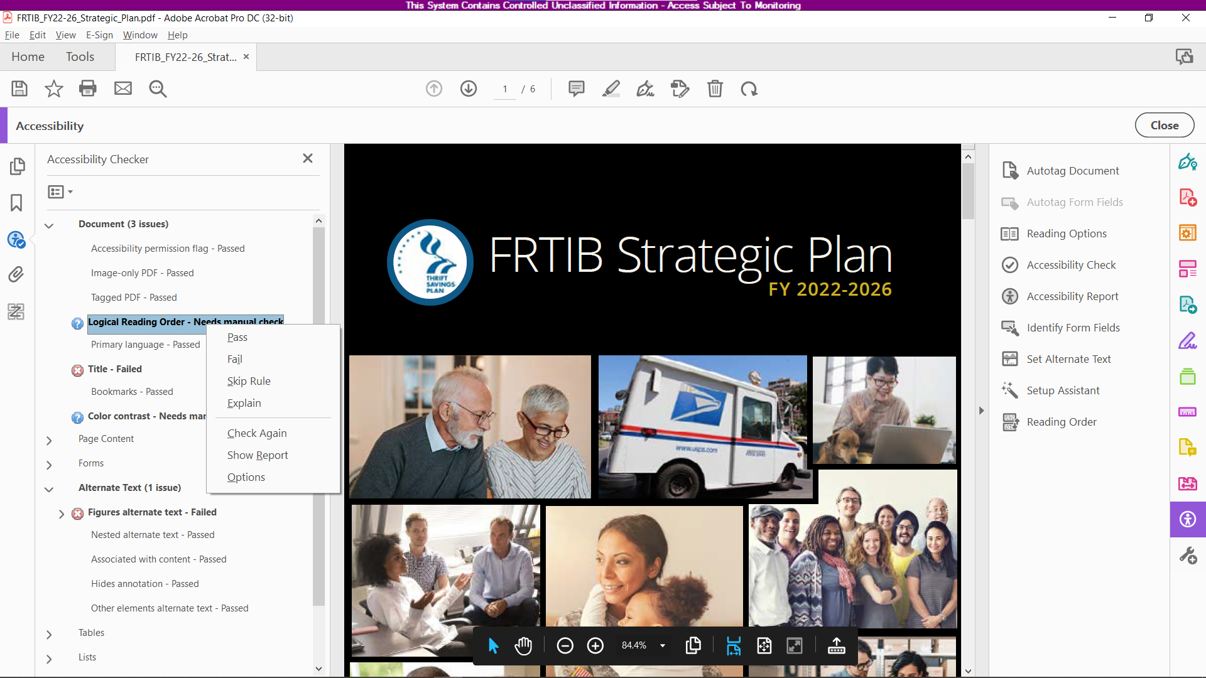

# Manual Edits to PDF for Accessibility

After Autotagging, pdfs will have a few erros that require manual editing and checking. This section will show how to fix the usual errors that will come up.

## Logical Reading Order – Needs Manual Check

**RESOURCE:** [Reading Order tool for PDFs (Adobe Acrobat Pro)](https://helpx.adobe.com/acrobat/using/touch-reading-order-tool-pdfs.html)

Logical Reading Order is the the order in which a screen reader or other visual assistive technology will read the content of the pdf.

If a user right clicks on this error message on the results on the report on the right pane, a browser window will launch an adobe.com page with further explanation/instruction.

**TIP: Save every time you edit.**

1. On the right Accessibility Tools pane, click on **Reading Order** (at the bottom of the list)

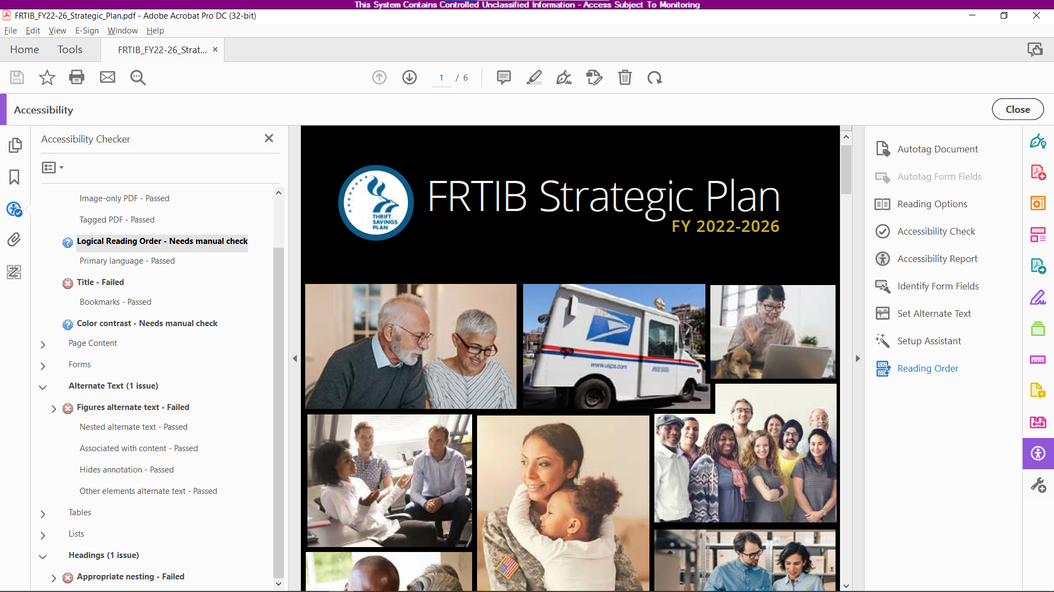

1. A new dialog box – Reading Order – will pop up, and the upper section with buttons for the types of content (Paragraph, image, header 1/2/3 etc) will be greyed out. The fields below will be checked automatically.  
     
   At the bottom of the dialog box is a **Show Order Panel** button. Click this to launch the Order Panel pane to the left of the PDF.

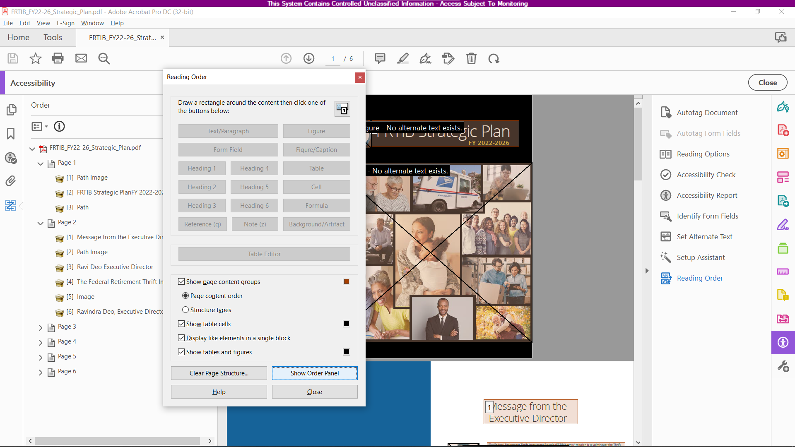

1. As you scroll down the PDF, you will see that sections are highlighted/boxed with numbers associated with said box. These numbers represent the reading order of the document.   
     
   You will also see where missing tags need to be added (in this page, images need alt text)

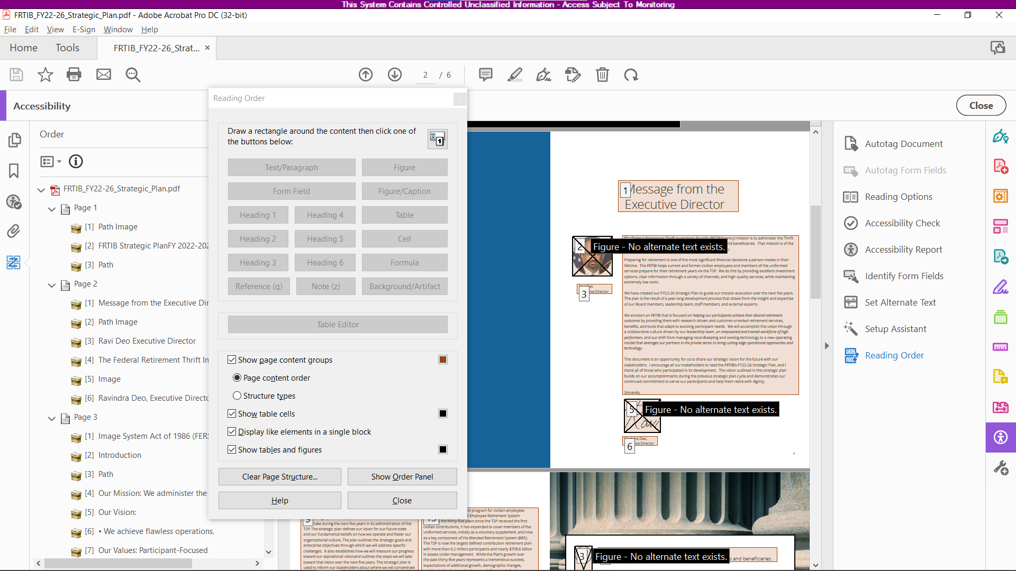

1. To add missing ALT tags to images, right click on the image in question and choose **Edit Alternate Text**. A dialog window will pop up where a descriptive text can be added.

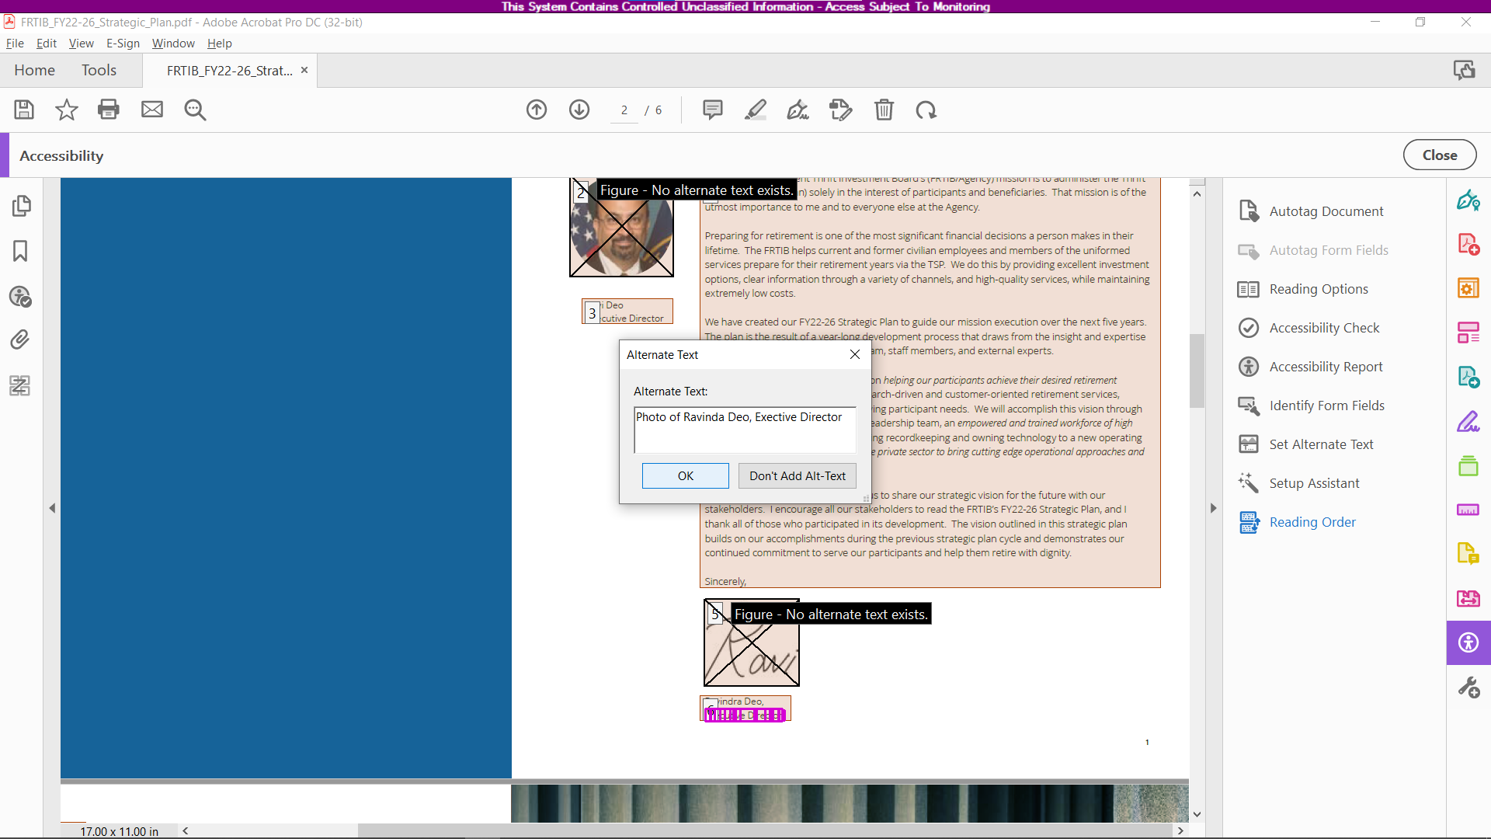

1. This page shows that the reading order is out of order. The screen reader will read this page as Image, Introduction, icons on the facing page, Our Mission and Our Vision on the facing page, then back to the left hand page with the actual content.  
     
   This page will need to be cleared and re tagged correctly.

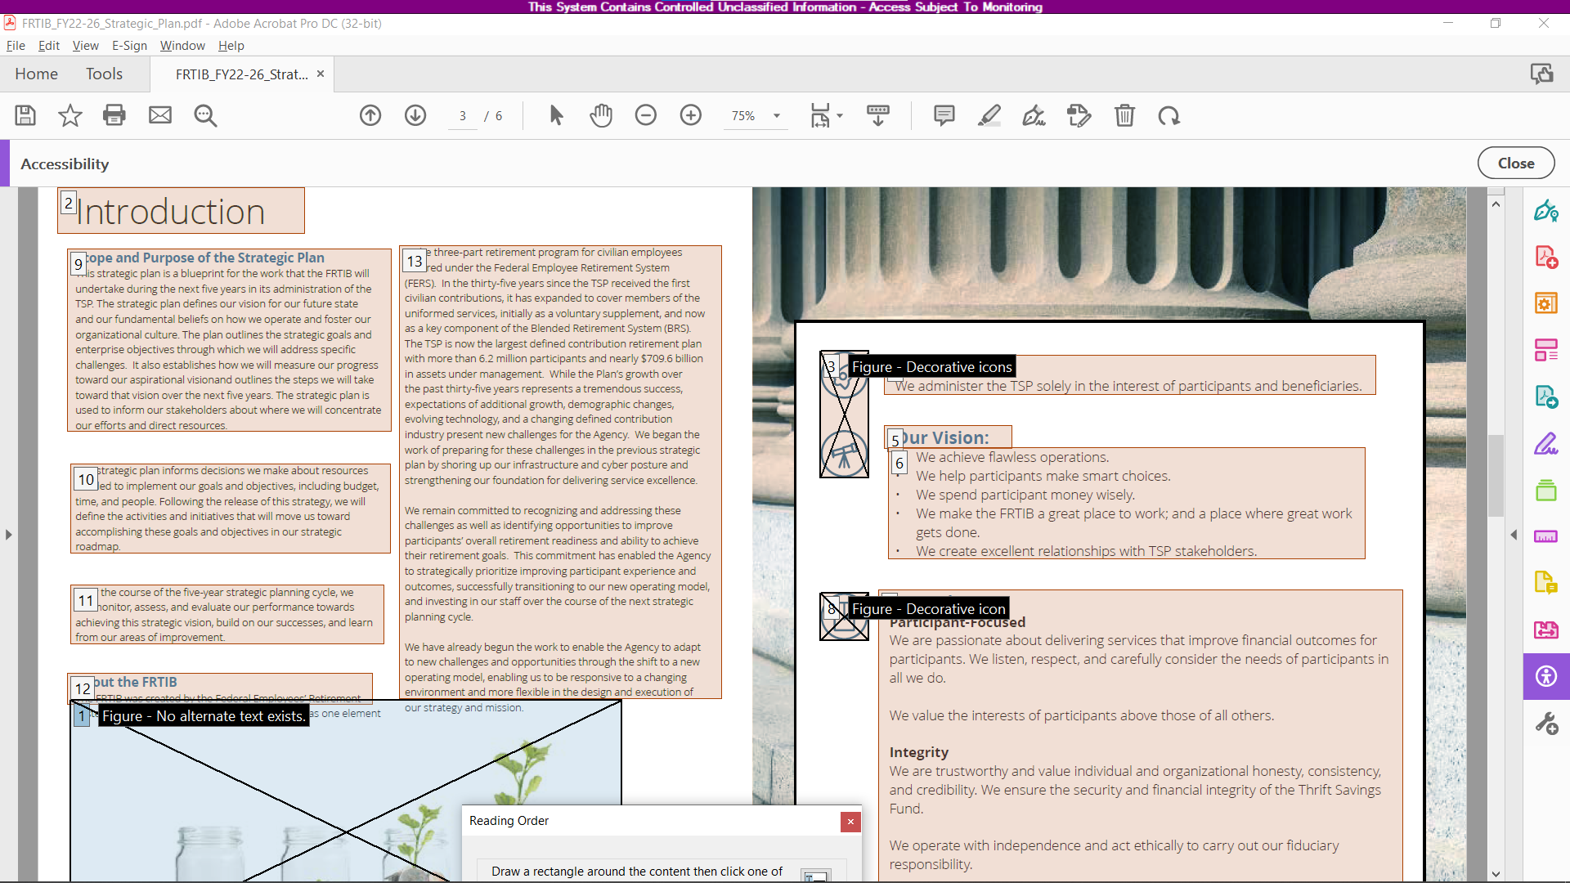

1. In the **Reading Orde**r dialog box, click on the **Clear Page Structure** button.

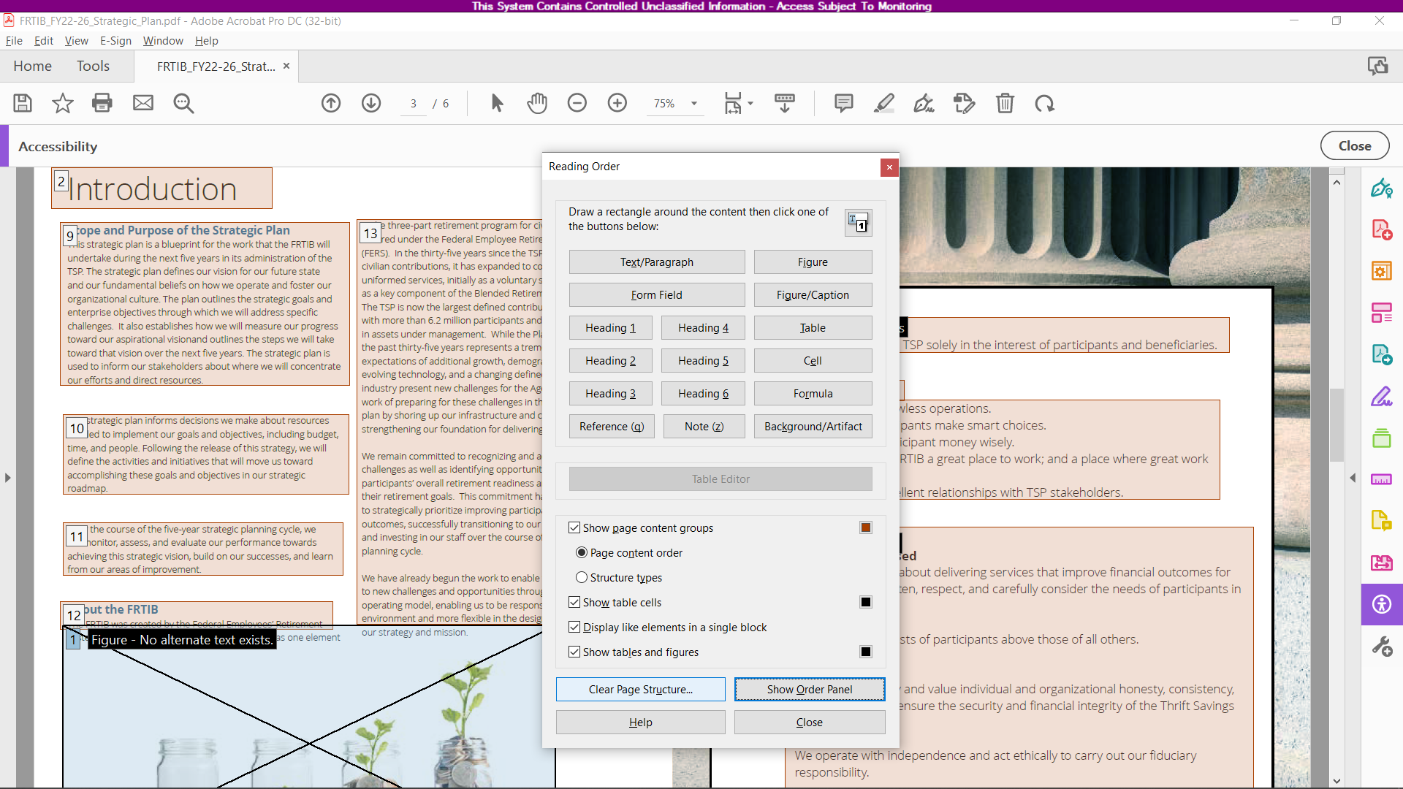

1. Once the page is cleared, all the numbered boxes will disappear.
2. Drag and draw a box around a piece of content – in this case, Introduction. Once that content is highlighted, options in the Reading Order dialog box will now be clickable.  
     
   As this is a main header, click on the Heading 1 button

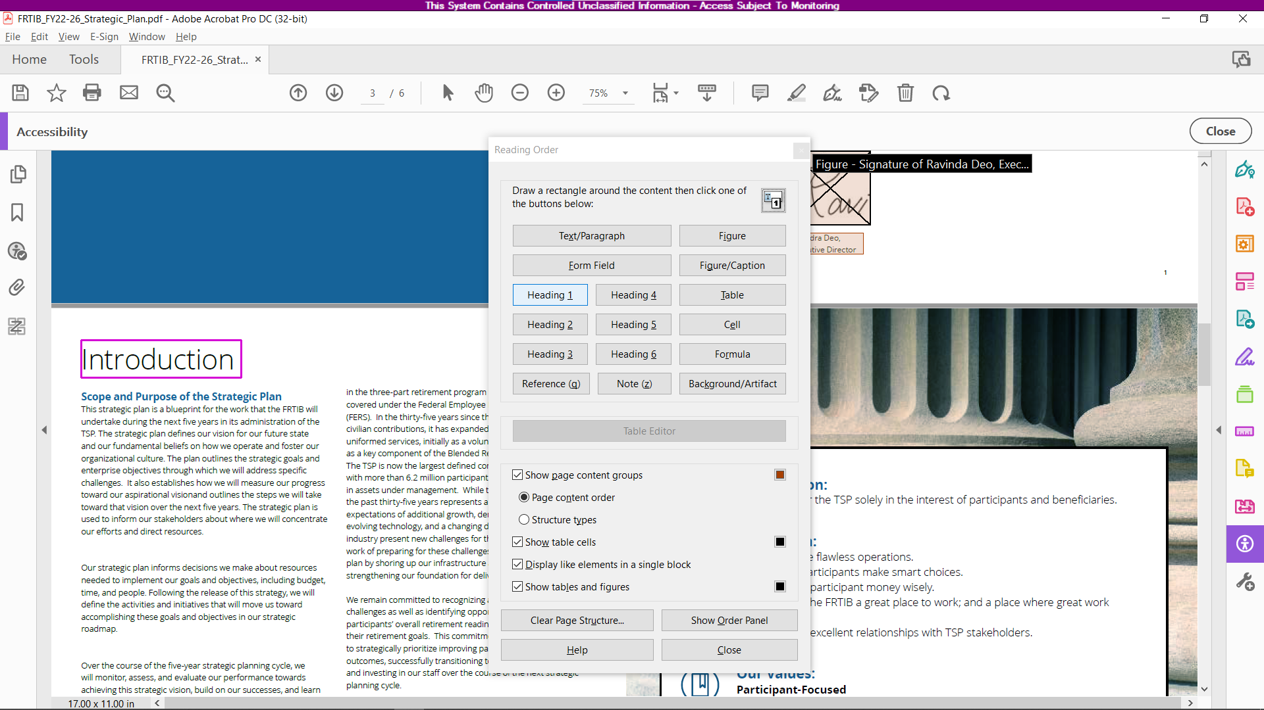

1. Once content is properly tagged, continue tagging the rest of the page, ensuring that the content will be read correctly and in order. Double check the reading order on the left pane.

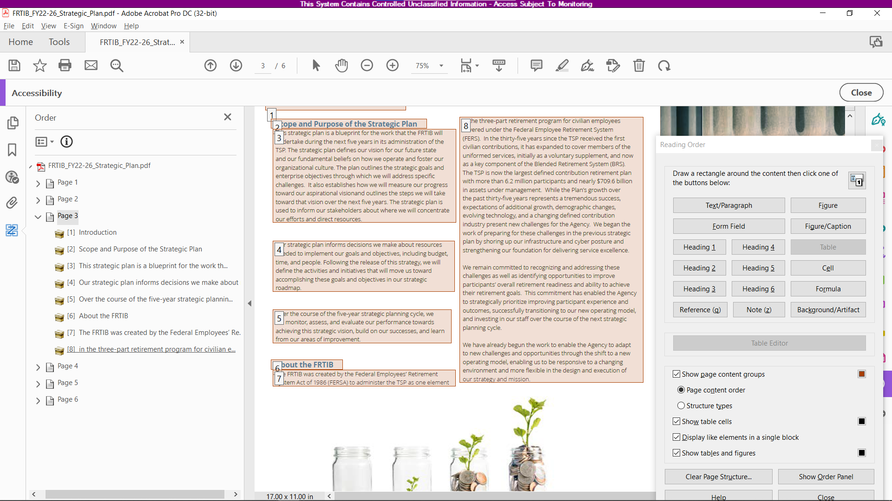

1. Occasionally, when tagging content manually, Adobe Acrobat will assign incorrect reading order to a newly tagged section. In this case, a header was assigned as #2 when it really should be #9.  
     
   You can see this incorrect order on the Reading Order pane on the left.

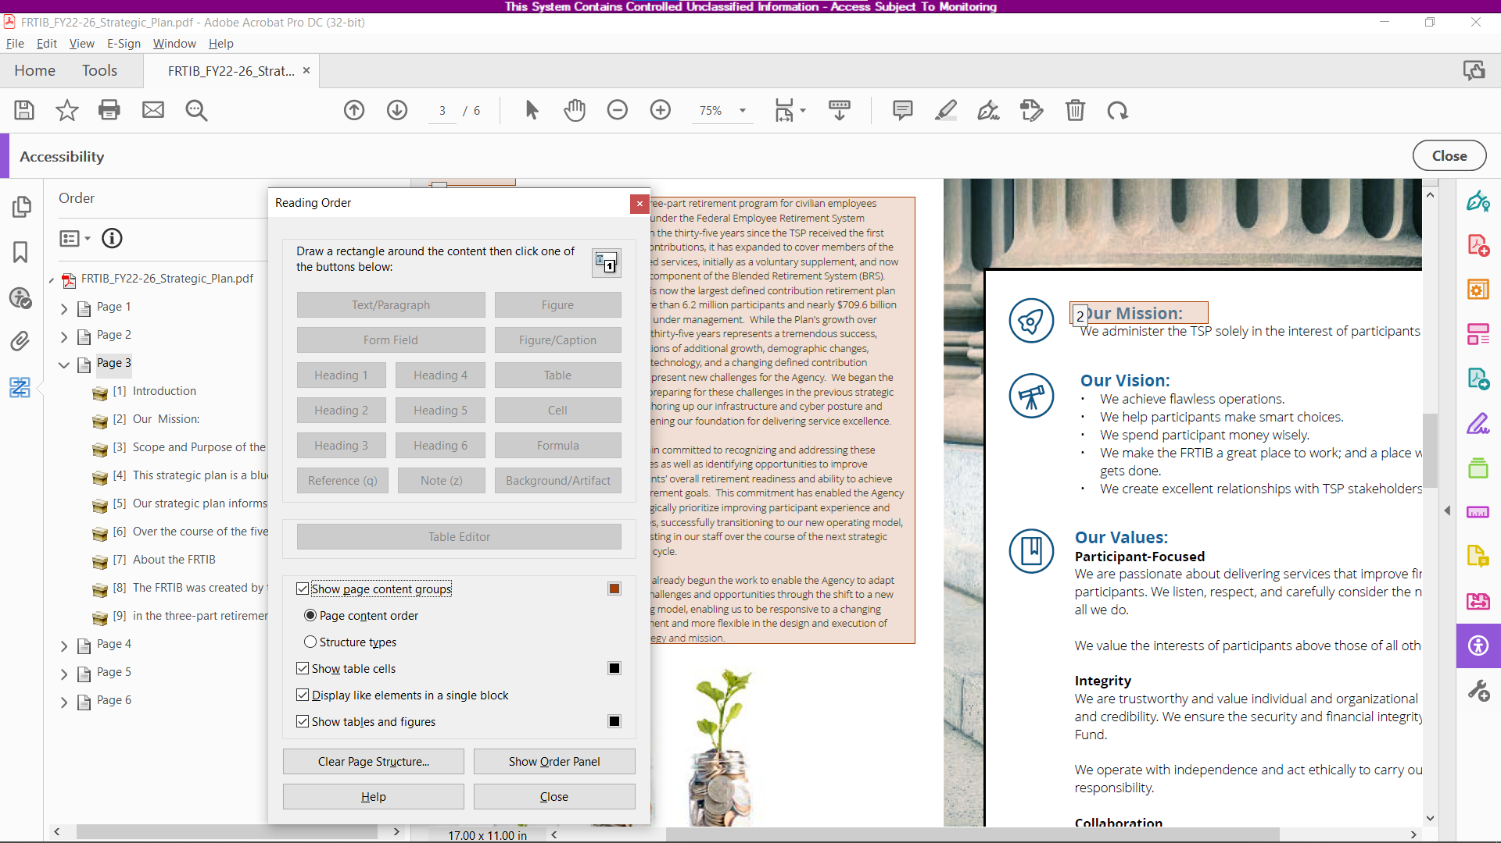

1. Drag and drop the incorrectly numbered item (in this case, from #2 to #9 position.   
     
   TIP: You can drag and drop multiple mis-ordered items at the same time by holding down the SHIFT button and clicking on the text that needs to be re-ordered.

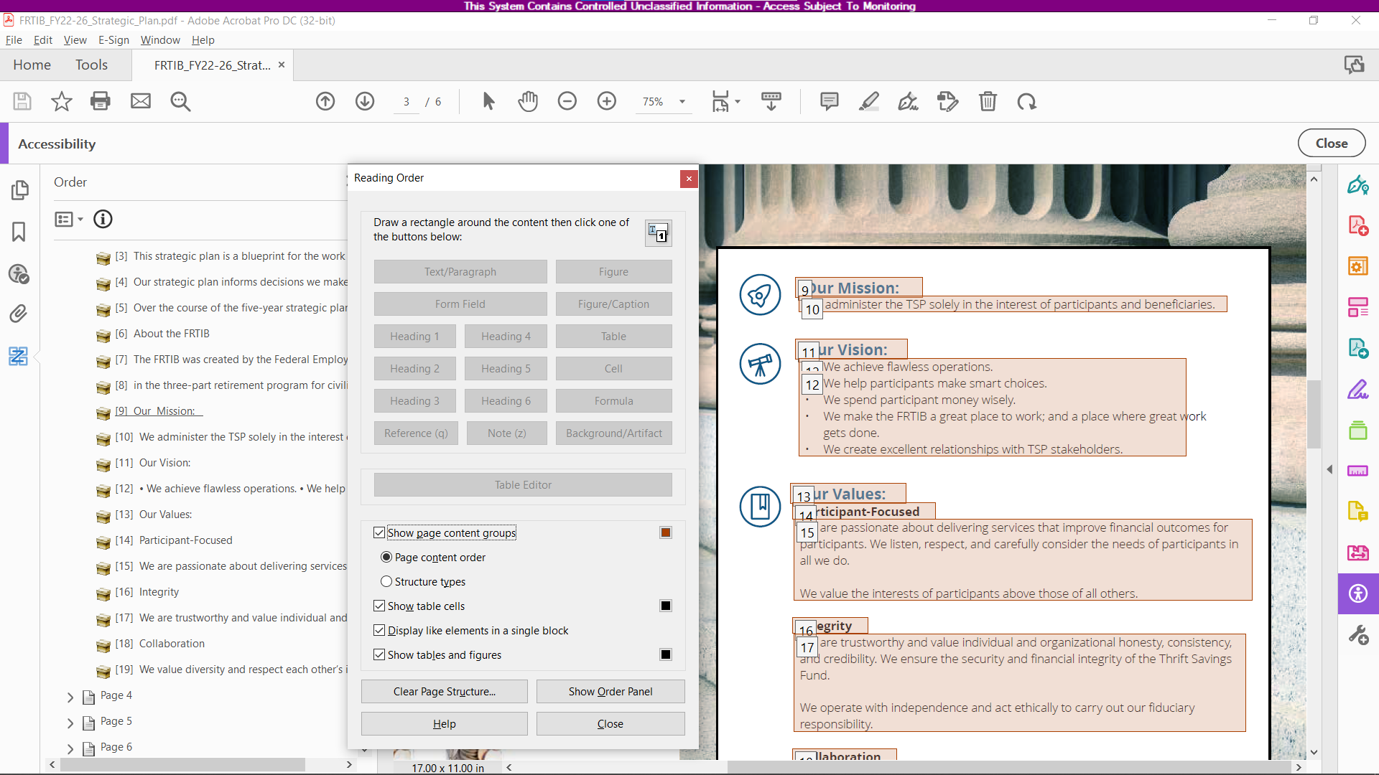

1. In the case of the image at the bottom of the page, there is an accompanying text that is associated with the image.   
     
   Click on the image to highlight it, hold down the SHIFT button and draw a box around the text, and choose FIGURE/CAPTION in the dialog box. Right click to add ALT Text  
     
   **TIP**: Move decorative images like this to the bottom of the reading order.

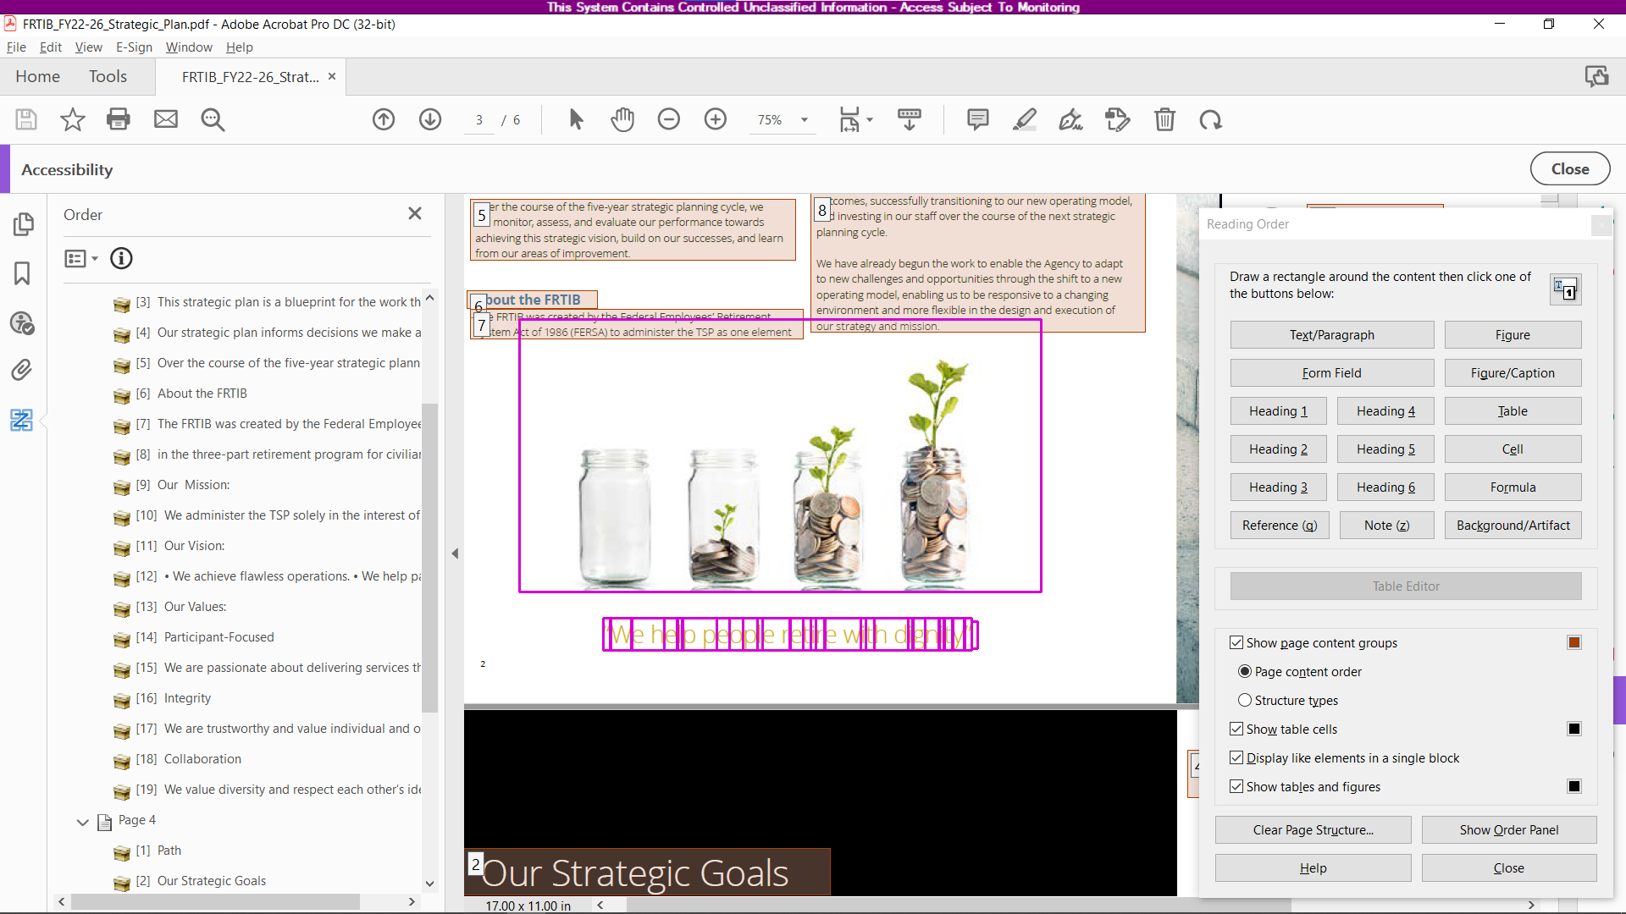

1. In the case of the background image, click on the image and tag as Background/Artifact. This will show up as “Path” on the Reading pane, move to the bottom of the reading list. This will be ignored by the screen reader.

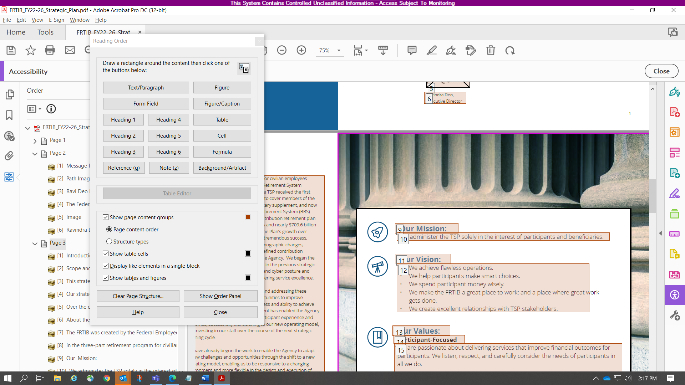

1. Once document is tagged and reading order has been fixed, run the **Accessibility Check** to find any further errors, and edit accordingly.